Element A: Identification and Justification of the Problem

Introduction
Each team member was tasked with creating 15 problem statements individually and was assigned to narrow them down to the top 3 with the Decision Matrix. This team consisted of Dhruv, Krish, Nick, and Omer. We used the Decision Matrix and feedback from our teacher and peers to decide on one problem that we all wanted to solve. We chose Krish’s prescription readability problem because we believed that if solved, it would help a large group of individuals. Since we understand the benefits of solving this problem, we will attempt our best to develop an adequate solution.

Problem Statement
According to the National Library of Medicine, 81% of older adults struggle to read medication names or doses, and 75% can’t clearly read expiration dates. As vision deteriorates with age, 66% of adults in the U.S. rely on some form of visual help, and by 2050, over half of the global population will require similar forms of visual corrections. This eyesight problem increases the likelihood of medication mix-ups, and it’s already affecting roughly 18% of individuals, leading to some form of mistake. With many adults taking more than five different types of prescriptions daily, there is an urgent need to develop an innovative solution that makes these labels clearer and safer.

Evolution of the Problem Statement
To create a strong problem statement, the team researched various aspects, including identifying key questions: Who, What, When, Where, Why, and How many people?. After identifying these key questions, we were able to create a strong problem statement. Then, we began working together to strengthen our problem statement from the previous one.
What? | Prescription labels are hard to read, causing medication errors
Why? | Age-related vision decline, small fonts, and poor label designs
Where? | Wherever individuals are taking medication, such as at home or in daycares
When? | Whenever individuals manage multiple prescriptions
Who? | Visually impaired individuals who take multiple prescriptions
How many people? | 81% of older adults struggle to read medication names or doses

Problem Statement Development
November 11th 2025  Problem Statement #1: | According to the National Library of Medicine, 81% of older adults struggle to read medication names or doses, and 75% can’t clearly read expiration dates. As vision deteriorates with age, 66% of adults in the U.S. rely on some form of visual help, and by 2050, over half of the global population will require similar forms of visual corrections. This eyesight problem increases the likelihood of medication mix-ups, and it’s already affecting roughly 18% of individuals, leading to some form of mistake. With many adults taking more than five different types of prescriptions daily, there is an urgent need to develop an innovative solution that makes these labels clearer and safer.
December 8th 2025  Problem Statement #2: | According to the Journal of the American Geriatrics Society, accurately reading a prescription label requires 20/20 visual acuity at a distance of 16 inches. This requirement isn’t met by 76% of older adults, making it difficult for them to understand necessary information on medication bottles, such as dosages, prescription names, and expiry dates. These readability issues contribute to the growing problem of at-home medication errors, affecting many adults who manage multiple prescriptions daily. Due to this, as many individuals rely on their prescriptions daily to manage various conditions, these vision-related difficulties create a risk of mix-ups. Therefore, a solution must be developed to improve both clarity and readability for older individuals who face such issues.
December 15th 2025  Problem Statement #3: | Older adults commonly struggle with age-related vision decline, which prevents them from accurately reading and understanding critical information on prescription labels, increasing the risk of medication errors. Research shows that accurately reading a prescription label requires 20/20 vision at 16 inches, a standard that 76% of older adults do not meet. These readability issues contribute to at-home medication mistakes, especially for individuals managing multiple prescriptions daily. Although solutions such as RFID talking labels improve safety, where 62% of users report feeling safer, they are limited by accessibility, cost, pharmacy willingness to participate, and reliance on technology. Other solutions, such as caregivers, can cost up to $30 per hour, making them expensive for many families. As the older population continues to grow and medication regimes become more complex, there is a clear need for an affordable, accessible solution that improves prescription label clarity and usability for visually impaired users.
December 16th 2025  Problem Statement #4 | Older adults struggle to accurately read and understand prescription labels due to age-related vision decline, small font sizes, poor label design, and complex medical instructions. Studies show that between 76% and 81% of older adults do not meet the visual requirements to read labels. From this, 18% of individuals are already experiencing mistakes. These challenges are heightened for individuals who manage multiple prescriptions daily, especially when pills look similar or labels are in unfamiliar languages. Current solutions, such as pillboxes, caregivers, and talking RFID labels, help but are often costly, inaccessible, or require technological familiarity. This issue is found at home, where older adults manage medications independently. Therefore, there is an urgent need for an affordable and accessible solution that improves label clarity, readability, and usability to reduce errors and support medication safety.

Final Problem Statement (1/13/2025)
Older adults often struggle to read and understand prescription labels due to age-related vision decline, small font sizes, poor label design, and complex medical instructions. Studies show that between 76 to 81 percent of older adults do not meet the visual requirements to read labels. 18% of individuals already experience medication errors. These challenges are greater for individuals managing multiple prescriptions, especially when pills appear similar or labels are in unfamiliar languages. Current solutions such as pillboxes, caregivers, and talking RFID labels offer support but are often costly, inaccessible, or require technological familiarity. This issue primarily occurs at home, where older adults manage medications independently. Therefore, there is a clear need for an affordable and accessible solution that improves label clarity, readability, and usability to reduce errors and enhance medication safety.

Pictures of the Problem
Pictures: | Description:
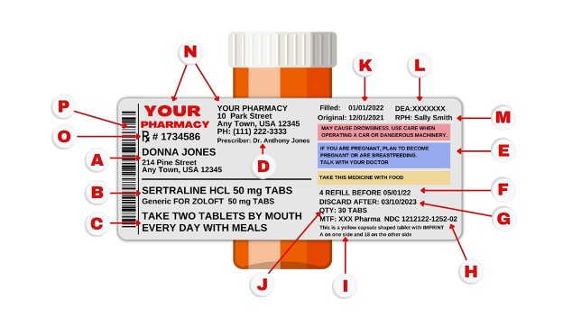  Source: https://www.consumermedsafety.org/safety-tips/learn-to-read-a-prescription-label | The label has different parts labeled A-P, containing small texts, dense formatting, and important information. Details such as dosage, warning, expiration dates, and instructions to consume are scattered across this small label, which would be extremely difficult for individuals whose eyesight is worsening and potentially dangerous if these directions are missed or not followed. The image of a standard prescription label visually demonstrates why medication readability is a serious problem. When critical information is compressed into tiny labels with small font, older adults and people with vision impairment must strain to read each piece of information, which increases the likelihood of misunderstanding or overlooking important medication labels.
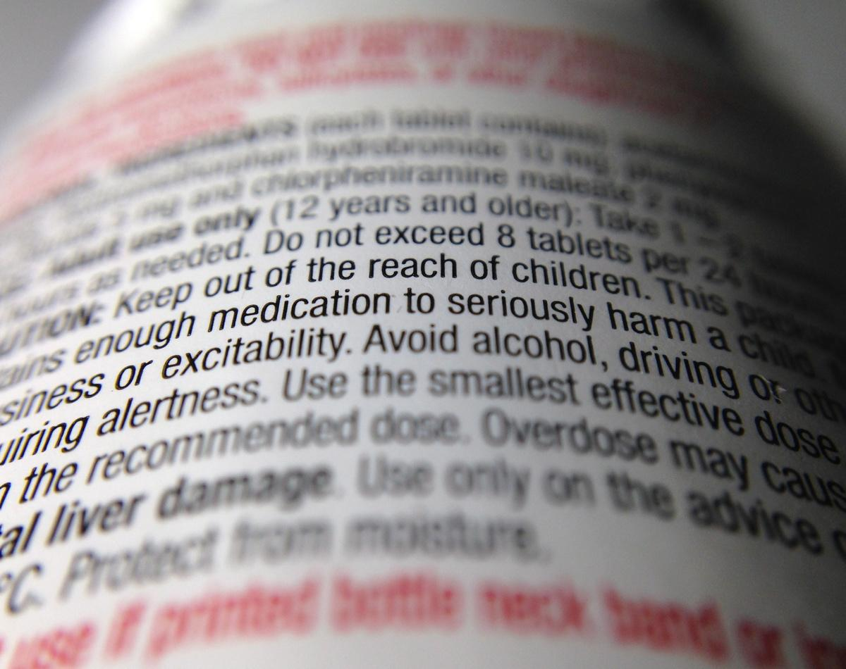  Source:  https://www.timescolonist.com/life/health/hard-to-read-drug-labels-cause-more-than-eye-strain-4611281 | The image displays warning information printed in a small font and placed in a visually crowded area of the prescription, making it difficult to read accurately. These critical safety details aren’t clearly emphasized and can be easily skipped. For individuals with weak eyesight, the clustered text makes it difficult to identify important safety hazards. This image demonstrates how poor label design and small text contribute to medication misuse. When safety information is difficult to read, visually impaired users are more likely to misunderstand instructions, which can result in serious health consequences.

Justification: Consumer Interview
Consumer Interview #1 (Conducted by Krish and Nick)
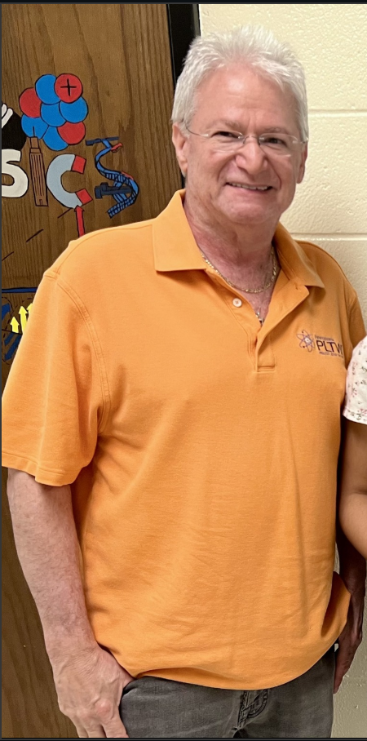 | Mr. Mazur - Teacher at PHS
Questions: | Answers:
How old are you? | 67 years old
Do you live alone? | No, I live with family
Do you use any form of visual correction? | Yes, I have been using glasses for 40 years
Have you been diagnosed with any vision-related conditions? | Yes, I have astigmatism in the right eye and a cataract
Do lighting conditions affect how well you can read medication labels? | Yes, I can read better in bright light and read worse in dim lighting
How many prescriptions do you take each day? | I take 4 medications daily, and most of them differ in size and shape. However, some have the same shape and size, making it difficult to identify them
Do you have any assistance that helps you take your medicine? | Yes, I use a pillbox that I update every week
What does your current medication routine look like? | I take medicine at night, and I remember I’ve taken it by leaving the pillbox open
Have you ever accidentally missed a dose or taken the wrong medication? | Yes, I accidentally took the wrong medication because I just placed the pill in the wrong box, or I just forgot
What issues do you face when reading or understanding medication labels? | Small texts, label peeling off when you’re trying to read more, understanding all of the details, and safety concerns. If I took medication A, is it safe to take medication B? What are the side effects of a medication?
Is the main issue: font size, too much text, hard-to-find information, poor lighting, or something else? | Font size
Do medications with similar shapes or labels ever confuse you? | Yes
Do you currently use anything to help you read medication labels? | Yes, I use a lightbulb with high brightness to read medication labels
Have you ever tried asking the pharmacy for clearer labels? | No
How comfortable are you with using technology? | I am comfortable using technology
How do difficulties with reading medication labels make you feel? | They don’t make me feel anything
If you could change one thing about medication labels, what would it be? | Font size
More Information: N/A
Reflection: This interview was very insightful, especially because I was interviewing my teacher. I expected Mr. Mazur to manage his medications pretty easily, but I learned that he struggles with reading small text and similar-shaped pills, which can lead to mistakes. One thing I found really interesting is that he uses a pillbox and bright light from his phone to help him, demonstrating how even small adjustments can make a huge difference. He emphasized the need for larger font sizes and stated that he would be willing to use technology to improve medication management. This interview highlighted the importance of practical solutions, like clearer labels, that reduce human errors. All in all, it made me realize how helpful real-life perspectives are in understanding problems that statistics can’t fully explain.

Justification: Consumer Interview
Consumer Interview #2 (Conducted by Krish)
This individual wishes not to be pictured. | Mrs. J Patel - Krish’s Grandmother
Questions: | Answers:
How old are you? | 83 years old
Do you live alone? | No, I live with family
Do you use any form of visual correction? | I have had glasses for 40 years. However, I use them only for reading or watching TV
Have you been diagnosed with any vision-related conditions? | Yes, I have been diagnosed with a cataract
Do lighting conditions affect how well you can read medication labels? | Yes, I can read better in bright light conditions and worse in dim lighting
How many prescriptions do you take each day? | I take 7 prescriptions daily, and they all differ from one another
Do you have any assistance that helps you take your medicine? | No, I remember everything by memory
What does your current medication routine look like? | I take it throughout the day, and I keep track that I’ve taken the medication by memory. Very rarely, my family reminds me to take it
Have you ever missed a dose or taken the wrong medication accidentally? | I have never missed or taken the wrong medication
What issues do you face when reading or understanding medication labels? | I can’t read anything because all of it’s in English, and I don’t know how to read English
Is the main issue: font size, too much text, hard-to-find information, poor lighting, or something else? | Some medications just don’t have names, and they’re hard to read
Do medications with similar shapes or labels ever confuse you? | I’ve never been confused
Do you currently use anything to help you read medication labels? | I just use my brain and muscle memory; I’ve been accustomed to it since then. When I first started taking the medications, someone informed me about when to take them, and that’s what I’ve followed since then
Have you ever tried asking the pharmacy for clearer labels? | No
How comfortable are you with using technology? | I will only be comfortable if I have been taught how to use it
How do difficulties with reading medication labels make you feel? | No, because I won’t ever take the wrong one
If you could change one thing about medication labels, what would it be? | More informative and larger texts
More Information: I have lived in India for the majority of my life, and most of my medication was prescribed in India.
Reflection: Interviewing my grandma was a pretty interesting experience, as I genuinely learned so much more about her. Before the interview, I expected her to miss a few doses; however, I was very surprised when she told me that she had never missed a dose. I gained valuable insight into how experience and habit play a crucial role in medication management, something that online research alone didn’t show me. I also learned that improving label readability and adding more information could still help, especially for new medications or those that are less familiar. This interview allowed me to realize the importance of talking to real people to understand their needs. After the conclusion of this interview, I realized that I would love to interview more individuals to gather even deeper insights.

Justification: Consumer Interview
Consumer Interview #3 (Conducted by Dhruv)
 | Amit Shah - Owner of Niramay Adult Day Care
Questions: | Answers:
How old are the individuals you work with? | They are typically between 65 and 95 years old
Do these individuals live alone at home? If not, with whom? | Some live alone, while others live with either a caregiver or family
Do they use any form of visual correction? What type? How long? | The majority of individuals use glasses
How many prescriptions do they take on average each day? Do they differ in size, shape, or color? | It depends on each individual; however, each individual takes roughly 5-6 medications, and most of them differ in shape
Do they require assistance when taking their medication? | Most do not require any assistance from family, caregivers, devices, or reminders
What is their usual medication routine? How do they keep track of doses? | They usually take medication after breakfast and after dinner
Have they ever missed a dose or taken the wrong medication? What contributed to it? | Yes, because of a lack of alertness. One client who experiences significant pain has accidentally overused medication because they forgot how much they already took, even with a caregiver present
What issues do they face when reading or understanding medication labels? | Most can’t read English or understand what the label is trying to say
Is the main issue font size, too much text, hard-to-find information, poor lighting, or something else? | Font size
Do medications with similar shapes or labels ever confuse them? | Yes, very often, especially because many individuals cannot read English
Do they currently use anything to help read labels? How well does it work? | Some memorize the bottle shape, translate labels into other languages, or use color-coding. After refills, someone usually needs to re-specify the medication information. These methods are helpful; however, they aren’t fully reliable
How versatile are they with technology? Would they use a device that helps? | Most are not versatile and often struggle to use their phones. They may be hesitant to use a new device
How do difficulties with reading labels make them feel? Has it affected their health or independence? | Yes. In one example, misunderstanding medication led to an emergency requiring an ER visit
If you could change one thing about medication labels, what would it be? | Larger font size, clear purpose of the medication, and labels provided in multiple languages
More Information: N/A
Reflection: Unlike the other interviews and results we retrieved from our survey, this interview gives the perspective of a caretaker. This helps us, as this one interview can represent years of caretaking of hundreds of different individuals. This also gave us a new target audience, as we could market our solution to adult day cares that can help them take care of elderly individuals easily. This also revealed another side of our problem, language barriers. Previously, we knew that elderly individuals would struggle to navigate technology, and this reinforced that, but it also added that complex medication names, lack of information, and inability to translate are factors to consider when we develop our solution. I truly believe that this interview will help us come up with the optimal solution.

Justification: Consumer Interview
Consumer Interview #4 (Conducted by Omer)
This individual wishes not to be pictured. | Afroze Anam - Omer’s Grandmother
Questions: | Answers:
How old are you? | 65-70 years old
Do you live alone? | No, I live with family
Do you use any form of visual correction? | Yes, I use glasses. I have been using it for almost twenty years
Have you been diagnosed with any vision-related conditions? | No
Do lighting conditions affect how well you can read medication labels? | Yes, I can read better in bright lighting and worse in dim lighting
How many prescriptions do you take each day? | I take almost 10 prescriptions each day, each of which differs in at least some slight way. They differ in color, shape, or size
Do you have any assistance that helps you take your medicine? | Yes, my daughter helps me with whom I live. I also use pillboxes
What does your current medication routine look like? | I take medication in the morning and at night. I keep track by using a pillbox, but my daughter also reminds me
Have you ever missed a dose or taken the wrong medication accidentally? | I have accidentally taken the wrong medication before, usually when I get new medicine that isn’t part of my routine already
What issues do you face when reading or understanding medication labels? | They are very hard to read, and they don’t make much sense. This is because English isn’t my first language, making it pretty difficult
Is the main issue: font size, too much text, hard-to-find information, poor lighting, or something else? | It’s a mix of font size, too much text, hard-to-find information, poor lighting, and other factors
Do medications with similar shapes or labels ever confuse you? | They sometimes do confuse me if I’m not fully focused
Do you currently use anything to help you read medication labels? | No
Have you ever tried asking the pharmacy for clearer labels? | No
How comfortable are you with using technology? | I know how to use technology; however, I would be pretty hesitant to use a new app or device comfortably
How do difficulties with reading medication labels make you feel? | I am indifferent to it
If you could change one thing about medication labels, what would it be? | I would make them simpler to understand and larger (in size and text)
More Information: N/A
Reflection: This interview was a very interesting experience for me, because at first it felt strange to be interviewing my own grandmother. However, throughout the interview, I realized that she had a lot more valuable information than I was expecting. By being able to interact one-on-one with someone who faced the problem themselves, I was able to understand exactly how deep the problem was and where to tackle it from, given a human perspective that online research and statistics wouldn’t have been able to provide. Given the opportunity, I would now love to interview many more people in order to get an even better understanding, and the interviews are going to contribute greatly to our design.

Justification: Consumer Interview
Consumer Interview #5 (Conducted by Nick)
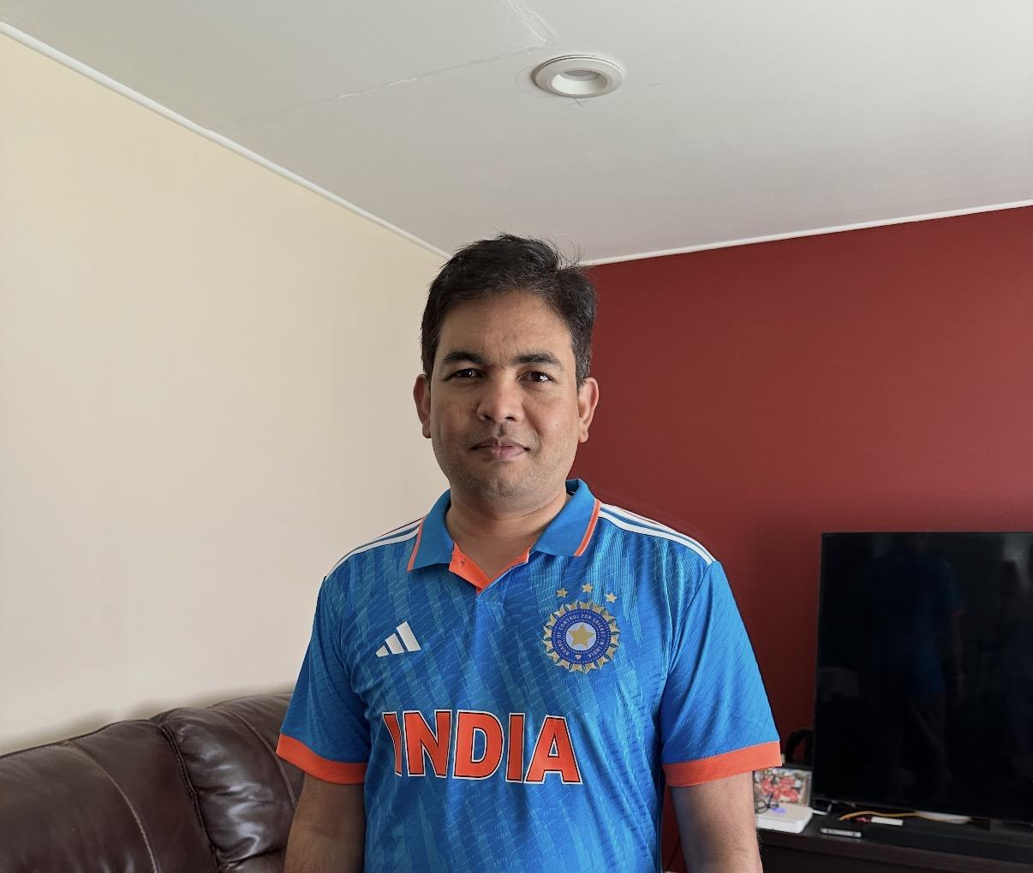 | Ketankumar Katara - Nick’s Father
Questions: | Answers:
How old are you? | 45 years old
Do you live alone? | No, I live with family
Do you use any form of visual correction? | Yes, I use glasses. I have had them for 7 to 8 years
Have you been diagnosed with any vision-related conditions? | No
Do lighting conditions affect how well you can read medication labels? | Yes, it’s better in bright light, and worse in dim lighting
How many prescriptions do you take each day? | I take 3 each day, and the size, shape, and color differ.
Do you have any assistance that helps you take your medicine? | No
What does your current medication routine look like? | I take medication in the morning and at night. I keep track of it by memory
Have you ever missed a dose or taken the wrong medication accidentally? | No
What issues do you face when reading or understanding medication labels? | None
Is the main issue: font size, too much text, hard-to-find information, poor lighting, or something else? | None
Do medications with similar shapes or labels ever confuse you? | No
Do you currently use anything to help you read medication labels? | No
Have you ever tried asking the pharmacy for clearer labels? | No
How comfortable are you with using technology? | No, I don't need technology. If I had to, I would be willing to use a device or app
How do difficulties with reading medication labels make you feel? | No
If you could change one thing about medication labels, what would it be? | Larger font
More Information: N/A
Reflection: This interview was interesting to say the least, because I’m interviewing my own dad. I expected my dad to have problems with reading medication labels, but throughout the interview, surprisingly, he had no problems, despite taking many medications each day, due to his being diabetic. I got good information on how he takes medication and asked him what he would change about medication labels, which was the point of having a larger font. Despite not having any trouble at all reading medication labels, he still wants to change the medication label to a larger font.

Stakeholders
Our potential users or buyers consist of a majority of older individuals who face vision-related difficulties and who also take multiple prescriptions daily. Given that many of these individuals will struggle working with technology, we aim to make our solution easily accessible for elderly individuals. While we haven’t observed any studies where this problem has occurred in younger groups, once we conduct our direct market research plan, we will be able to identify trends in both elderly and young groups, allowing us to identify our problem.
Another possible buyer could be adult day care centers and personal caregivers. These groups are tasked with organizing, monitoring, and administering medication, and a versatile solution would reduce errors, save time, and improve the quality of care. For widespread use, pharmacies that frequently handle medications will also be a major stakeholder for our problem, as they could help spread this product to consumers who face our problem. Lastly, after we conduct our marketplace research, we will be able to properly identify if this issue also occurs among young individuals. This will expand our stakeholders to a much larger audience that could benefit from the solution we derive later.

Scholarly Article #1
Article Title: ScriptTalk Talking Labels

Content:
ScriptTalk is a tool that utilizes RFID/NFC labels placed on prescription bottles. The machine scans these labels, and when the device or app scans it, the device or the app reads audio instructions, including the medication name, dosage, and other critical information. 1q

Citation: Talking prescription labels: ScripTalk. ScriptAbility.com. (n.d.). https://www.scriptability.com/scriptalk-talking-labels

Scholarly Article #2
Article Title: HOME ALONE REVISITED: FAMILY CAREGIVERS PROVIDING COMPLEX CARE

Content:
The role of family caregivers has expanded far beyond basic support. A national survey by UHF and the AARP Public Policy Institute reveals that caregivers now regularly perform complex medical and nursing tasks that were previously done in hospitals.
- 42 million unpaid family caregivers exist in the U.S.
- 46% of caregivers perform medical/ nursing tasks at home
- 75% of these caregivers manage medications, including IVs and injections
- Over one-third provide wound care, which trained clinicians usually handle
- The artifact highlights how modern caregiving provides crucial medical support that helps patients stay at home rather than in hospitals

Citation: United Hospital Fund. (2019). Home Alone: Family Caregivers Providing Complex Chronic Care | United Hospital Fund. United Hospital Fund. https://pmc.ncbi.nlm.nih.gov/articles/PMC6846337/

Scholarly Article #3
Article Title: Enhancing Medication Safety: Evaluating Prescription Label Readability Among the Elderly

Content:
The study showcases how label design affects older adults’ ability to read and understand prescription labels. In the study, they redesigned prescription labels with a 14-point font for better visibility. They also formatted much better and removed unnecessary information. Dedicated warning sections were placed directly under the dosage instructions to ensure no one can skip over them. Expiration dates were added, and a standardized format was created to improve consistency.

Citation: Zakaria, F., Zakaria, I., & Tjahjaningsih, E. (n.d.). Enhancing medication safety: Evaluating prescription label readability among the elderly. International Journal of Research and Innovation in Social Science. https://rsisinternational.org/journals/ijriss/articles/enhancing-medication-safety-evaluating-prescription-label-readability-among-the-elderly/

Scholarly Article #4
Article Title: Effects of label format on knowledge acquisition and perceived readability by younger and older adults

Content:
The study examines how adults acquire information from simulated over-the-counter medication labels and their preferences for label features. In the study, older adults were found to perform better with larger print compared to small print, and younger adults performed well regardless of the print size. Younger and older adults preferred to have labels that had more white space; however, this had a significant effect on the amount of information on the label itself. Pull-out labels tremendously helped older adults as they stored a lot of extra and important information.

Citation: VIGILANTE, M. S. W. W. J. (2003). Effects of label format on knowledge acquisition and perceived readability by younger and older adults. Ergonomics, 46(4), 327–344. https://doi.org/10.1080/0014013021000048006

Scholarly Article #5
Article Title: The impact of simulated visual impairment on the medication use process: A study with healthy volunteers

Content:
This simulation examines how visual impairment affects the ability to identify and use medications. In the simulation, a healthy volunteer wore glasses that simulated different levels of visual impairment while attempting to read medication packaging.
- At moderate visual impairment, 81% of participants could not read medication names or doses
  - 75% could not read full expiration dates
  - 60% could not read patient information leaflets
- Simulated moderate impairment reduced reading speed to about 44 words per minute
- At severe levels of simulated impairment, participants could no longer identify medication boxes at all

Citation: Merenda, Théodora, et al. “The Impact of Simulated Visual Impairment on Medication Use Process: A Study with Healthy Volunteers.” Exploratory Research in Clinical and Social Pharmacy, vol. 18, June 2025, p. 100581, https://pmc.ncbi.nlm.nih.gov/articles/PMC11910069/

Scholarly Article #6
Article Title: OVER-THE-COUNTER MEDICATION LABELS: PROBLEMS AND NEEDS OF THE ELDERLY POPULATION
Content:
This letter highlights the challenges older adults face with OTC medication labels and the need for improved readability and accessibility. The problem identified was that older adults often struggle to read OTC labels due to the small font size. This directly affects the older adults, as they are the largest OTC consumers and are particularly vulnerable to misuse due to polypharmacy.
- Current FDA labels don’t adequately address older adults’ needs
- Proposes that prescription labels are larger for better readability and labels that talk similarly to ScriptTalk

Citation: Pawaskar, M. D., & Sansgiry, S. S. (2006). Over-the-counter medication labels: Problems and needs of the elderly population. Journal of the American Geriatrics Society, 54(12), 1955–1956. https://doi.org/10.1111/j.1532-5415.2006.00958.x

Scholarly Article #7
Article Title: Improving the legibility of prescription medication labels for older adults and adults with visual impairment
Content:
The artifact evaluates how current prescription medication labels compare to prototype labels designed using the best legibility guidelines and how older adults and visually impaired adults read and prefer them. The study compared current pharmacy-issued prescription labels with prototype labels designed based on legibility best practices (font size, consistent layout, and highlighted numeric instructions).
- Participants read prototype labels' significance faster than current sample levels, demonstrating improved efficiency
- Participants from all groups preferred the largest print size and instructions where numbers were written in uppercase words
- Insights into how design changes could reduce reading effort and potentially support safer medication use

Citation: Leat, S. J., Krishnamoorthy, A., Carbonara, A., Gold, D., & Rojas-Fernandez, C. (2016). Improving the legibility of prescription medication labels for older adults and adults with visual impairment. Canadian Pharmacists Journal, 149(3), 179–188. https://pmc.ncbi.nlm.nih.gov/articles/PMC4860753/

Survey (Prescription Label Readability)
Gathered from the Public
Method of Distribution:
- Schoology Updates & Social Media
Question 1
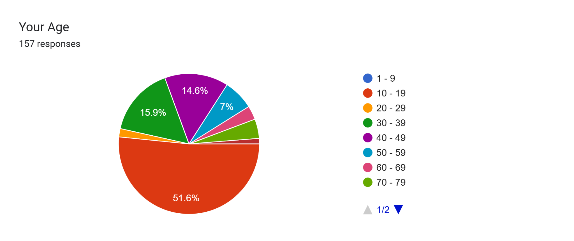
Reflection:
The respondent pool is predominantly young, with 51.6% in the 10-19 age range. However, there is a diverse spread across middle-aged and older populations. The heavy skew toward younger individuals suggests the results may reflect a “baseline” of readability for those with generally better eyesight, making issues reported by the older demographic more significant.

Question 2
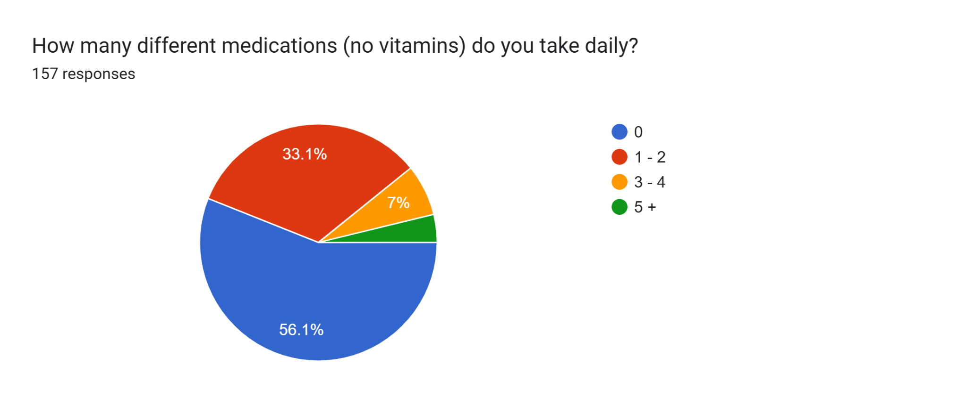
Reflection:
A majority of respondents (56%) do not take any daily medications, while 33% take between 1 and 2. Only a small fraction manages 3 or more daily prescriptions. Since most respondents aren’t frequent users of prescription labels, their difficulty in reading them may stem from a lack of familiarity or inherent design flaws rather than “label fatigue.”

Question 3
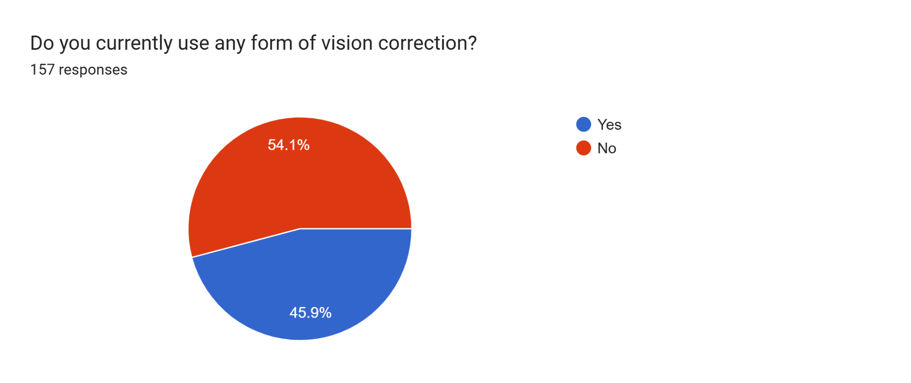
Reflection:
There is a nearly even split in vision correction usage, with 46% using glasses or contacts and 54% not using any. The high percentage of vision correction users highlights that prescription labels must be designed to accommodate those with varying degrees of visual impairment.

Question 4
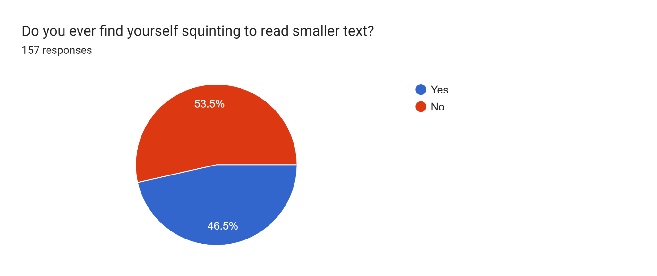
Reflection:
Approximately 46.5% of respondents admit to squinting to read smaller text, closely mirroring the vision correction statistics. Squinting is a common behavioral indicator of poor readability, suggesting that a significant portion of the population finds standard small-print text physically straining.

Question 5
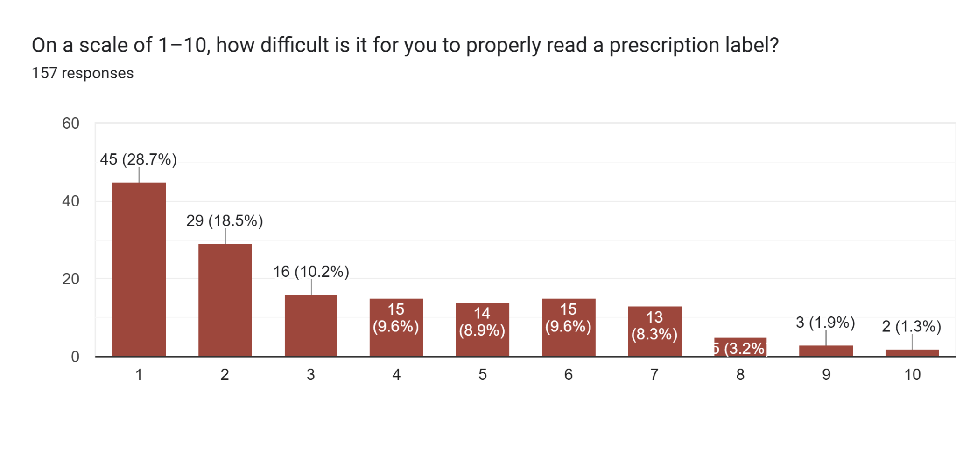
Reflection:
The average difficulty score is 3.5, indicating it is generally “easy” for most. However, 24% of respondents rated the difficulty at a 6 or higher, showing a significant minority struggle significantly. While the majority navigate labels, a “one-size-fits-all” design fails nearly a quarter of the population, posing a potential safety risk for medication errors.

Question 6
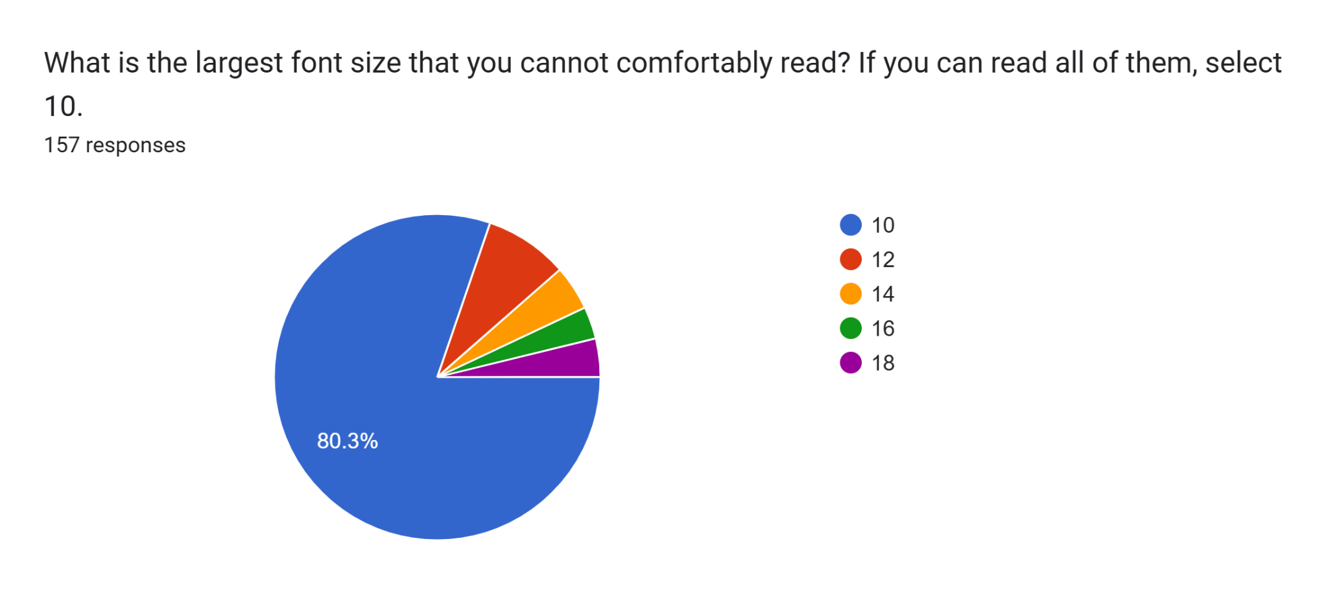
Reflection:
Most respondents (80%) can comfortably read font size 10. For those who cannot, the most common “limit” is size 12, which is a standard size for many documents. If font size 10 is the floor for most, any text smaller than this (which is common on prescription bottles) will likely be illegible to a large portion of users.

Question 7
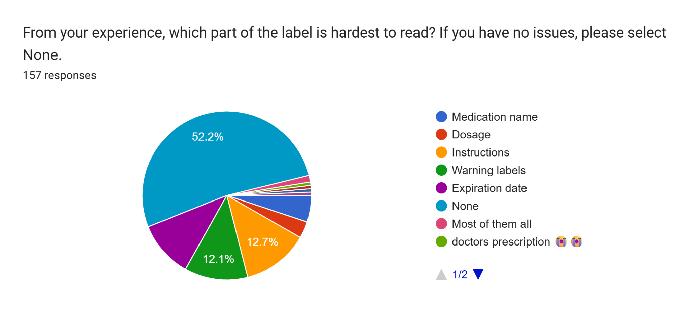
Reflection:
Aside from those with no issues (None), the Instructions, Warning Labels, and Expiration Dates were cited as the most difficult sections to read. It is concerning that the most critical safety information (warnings and instructions) is often the hardest to read, suggesting a need for better hierarchy and layout in label design.

Existing Solutions (ScriptTalk)
The first existing solution to the problem we are addressing is Talking & RFID Labels, like ScriptTalk. These can be scanned with readers at pharmacies or with certain smartphones and will play audio instructions and other key information about the medication. According to a study conducted by ScriptTalk, “Just under two-thirds (62%) of those questioned said they feel safer because they know they are taking the right medication/dosage. And more than one-third (37%) of respondents said they feel safer taking their medications because ScripTalk reads them all the information they need to ensure they are taking the right medication.” While the data proves that this solution has increased users’ comfort level while taking medication, this solution still poses many flaws. RFID readers like ScripTalk require the pharmacy to place an RFID/NFC tag on the medication container. Then users must download an app and scan the tag. The video demonstration on their website includes how it will not always scan on the first go, and users must move it around to scan it, which can be a minor problem. (Talking Prescription Labels | ScripTalk, n.d.) There are also risks of the RFID tag being damaged or broken. The major problem is accessibility. First, these RFID labels are only provided by major pharmacies like CVS and Walmart. This leaves out independent pharmacies, small chains, and rural ones, which might be the only ones for an individual. Second, older users might not be able to fully be able to navigate the app fully or may not even own a smartphone. One of our main goals for our solution is accessibility, especially since we are targeting an older audience, and we want any pharmacy to get it, given that the cost of the RFID implementation comes out of the pharmacy.
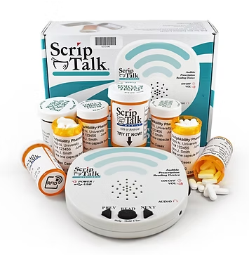

Citation: Talking Prescription Labels | ScripTalk. (n.d.). ScriptAbility.com. https://www.scriptability.com/scriptalk-talking-labels

Existing Solutions (CareTakers)
The next solution we will examine is human caretakers. The family of an elderly person hires these individuals to take care of the elderly person. This may include cooking, tidying up 4the place, and, most importantly, organizing medication and administering it to the individual. Given that extremely old individuals have deteriorated eyesight, these caretakers replace the need for them to read, interpret, or manage medication labels. However, while this seems really good, it comes at a massive cost. Professional caretakers can cost $15–$30 per hour, often totaling thousands of dollars per month, which is not achievable by most families. (U.S. BUREAU OF LABOR STATISTICS, 2024) Second, caretakers are still humans, and the potential risk of human error, while it is low, still exists. Poorly trained ones can mix up or confuse medication, which is a danger to their patient. Lastly, most caretakers may only visit a few hours per day, and are often not present during common medication times such as morning and evening. (United Hospital Fund, 2019) One goal of our solution is to be able to use it at any time, making it affordable and easy for anyone to have.

Citation:
United Hospital Fund. (2019). Home Alone: Family Caregivers Providing Complex Chronic Care | United Hospital Fund. United Hospital Fund. Home Alone: Family Caregivers Providing Complex Chronic Care : Publications | United Hospital Fund
U.S. BUREAU OF LABOR STATISTICS. (2024, August 29). Home Health Aides and Personal Care Aides: Occupational Outlook Handbook: U.S. Bureau of Labor Statistics. Bls.gov. https://www.bls.gov/ooh/healthcare/home-health-aides-and-personal-care-aides.htm

Existing Solutions (Pill Boxes)
Lastly, commonly used by those who take several medications are pill boxes or organizers. These are plastic containers that allow individuals to allocate their medication for a duration of time, like a week or a biweek. While an individual would only have to do this at the start of a month or week, it is still prone to error and relies on the user correctly sorting pills (high risk of error). These containers only store pills; they don’t contain information on how to consume, dosage amounts, or other important data (Straka et al., 2022). Our solution aims to help limit this risk of error by ensuring adequate information is provided to safely consume the medication is provided to help the user.

Citation:
Straka, I., Minar, M., Grofik, M., Skorvanek, M., Bolekova, V., Gazova, A., Kyselovic, J., & Valkovic, P. (2022). Effect of Pillbox Organizers with Alarms on Adherence to Pharmacotherapy in Parkinson Disease Patients Taking Three and More Daily Doses of Dopaminergic Medications. Journal of Personalized Medicine, 12(2), 179. https://doi.org/10.3390/jpm12020179

Conclusion
With the help of numerous interviews, surveys, and scholarly articles, the team concludes that our problem statement: “Older adults struggle to accurately read and understand prescription labels due to age-related vision decline, small font sizes, poor label design, and complex medical instructions. Studies show that between 76% and 81% of older adults do not meet the visual requirements to read labels. From this, 18% of individuals are already experiencing mistakes. These challenges are heightened for individuals who manage multiple prescriptions daily, especially when pills look similar or labels are in unfamiliar languages. Current solutions, such as pillboxes, caregivers, and talking RFID labels, help but are often costly, inaccessible, or require technological familiarity. This issue is found at home, where older adults manage medications independently. Therefore, there is an urgent need for an affordable and accessible solution that improves label clarity, readability, and usability to reduce errors and support medication safety.” is both justified and accurate. From our research, we concluded that the main group of people we will develop our solution for is visually impaired individuals who get mixed up managing several prescriptions. Additionally, our survey supported that 45.1% of respondents use a form of visual correction. This highlights how vision has begun deteriorating for most teens. Therefore, we could broaden the scope of our solution to a larger age audience. In other words, we have broadened the scope of the solution, ensured that it is affordable, accessible, and easy to use. All in all, our research can greatly help us develop a better solution that reduces medication errors of millions of individuals worldwide.

Element B: Documentation and Analysis of Previous Solution Attempts and Justification of the Problem

Patent Researched 1: 7,540,880 B1
Citation: Austin, P. R., & German, K. A. (2008, November 25). Personalized medication packaging.

Summary: The following patent is a device that allows users to create their own medication labels to replace the existing ones already on the container. It utilizes a CPU and a user interface to dispense the correct medicine based on input from the processing device. Then, it generates and prints a “receipt” with information about the medicine they have taken out. Then, it seals the dispensed medicine with personalized packaging configured with the custom information. The stated purpose is to provide clear and personalized information about the medication to avoid misuse.

Critique: The patented item attempts to solve a similar problem to ours by aligning itself with our mission. Our goal is to make sure people who take medicine don’t get confused with the medicine they’re taking by identifying label readability as the main issue. This patented item circumvents the entire issue of label readability by creating an entirely new interface and device that automatically sorts and dispenses the medicine, with custom labeling, using a UI. Some good attributes of this item are that it is very practical and is almost guaranteed to prevent confusion and accidents. However, some potential issues may pertain to certain age groups. For example, older people might not be accustomed to this new technology. Furthermore, even though it seems very effective, it is certainly very costly and not easy to develop. This patent allowed us to see that there is definitely more than one way to tackle this problem. We thought the goal was just to make labels easy to read, but another solution may just be to remove the problem entirely from the equation.

Images
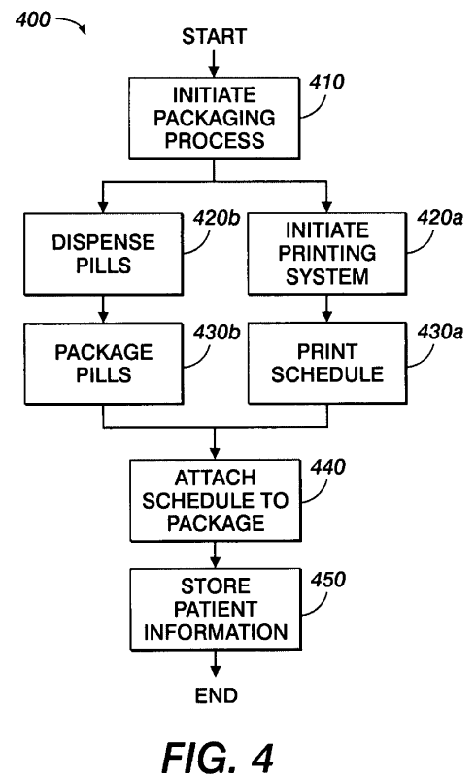
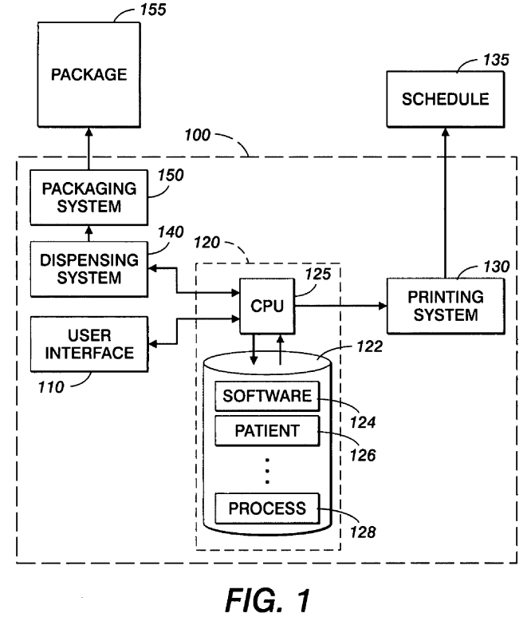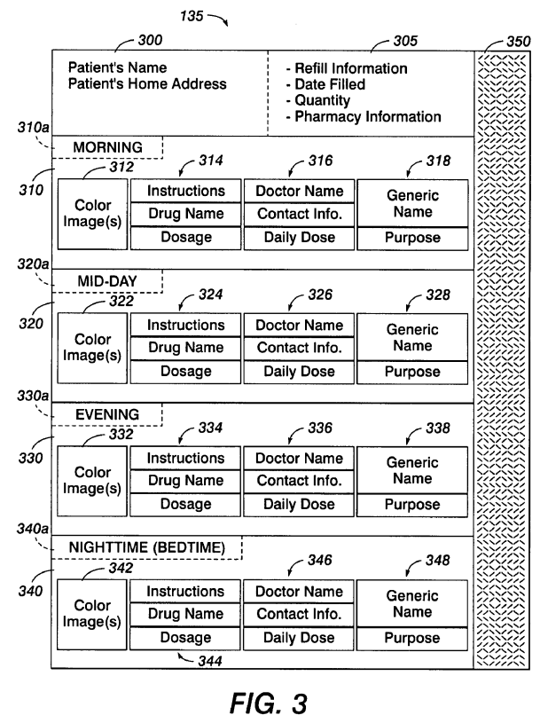

Strengths | Shortcomings
This patent demonstrates a product that allows users to make a label with the medication information they choose and will provide clear instructions, medication names, dosage, and timing, making it easier for users to understand how and when to take their medicine. | Our primary target audience is elderly individuals, and this advanced technology might not be easy for them to navigate by themselves. On top of this, this product appears to be very costly and hard to manufacture, reducing its accessibility in helping many who face prescription readability issues.

Patent Researched 2: JP2004017999A
Citation: Tanimura, S. (2004). Method for labeling medicine bottles (Japanese Patent Publication No. JP2004017999A). Japan Patent Office.

Summary: This patent applies a method for labeling small medicine bottles (such as vials), which are commonly used in the clinical and hospital setting. The main focus is on the positioning of these labels and also having additional informative labels where space is typically limited. Instead of placing info on the limited side surface or manufacturer label area, this method involves affixing the label to the bottom, flat surface of the medicine bottles. It’s designed to perfectly fit the information necessary while simultaneously keeping it readable. This method makes the additional info easier to read and scan.

Critique: This patent attempts to solve a similar problem in a slightly different setting. Whereas we are tackling medicine label readability for customers and recipients of prescription-based medicine, this patent attempts to solve the issue of readability and packaging for those in hospital and higher medicine environments, namely by targeting label readability and keeping information useful and intact. This solution is likely going to be pretty effective for those who handle these small vials and containers daily, as it's directly intended for them. However, this solution raises some issues, as it demands remanufacturing and a shift in the entire printing process for labels on vials and small containers, rather than actually making existing prints easier to read and understand. Of course, if it is implemented on a wide scale, it would be useful, but as an idea alone, it is not very effective. However, this has shown us that we should consider solving the label’s own issues as well. We need to make sure we keep all the information intact, as it is all clearly very useful information. Additionally, if Japanese inventors are able to increase readability on the tiniest of packages, it actually relieves us of some stress, as it shows us we can also do the same for labels that are already larger in size.

Images
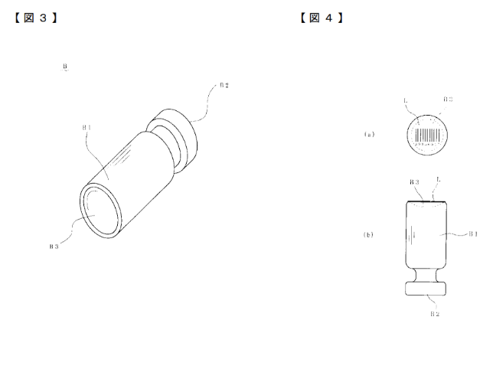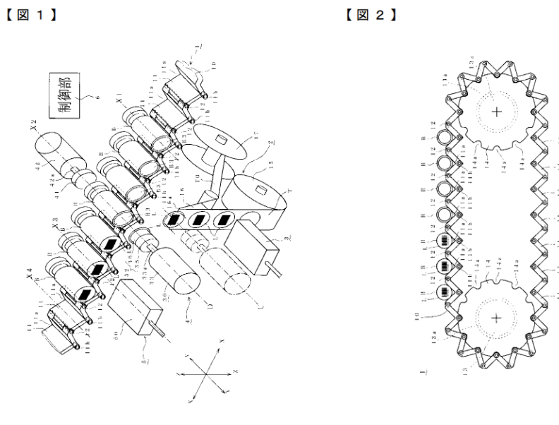
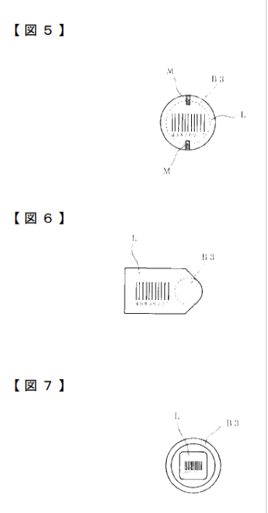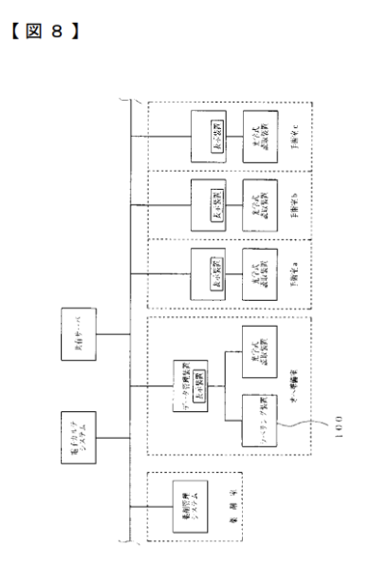

Strengths | Shortcomings
This patent aims to improve the readability and scanning of information on small medicine bottles. This allows more information to be included without crowding the existing label. While it is designed for frequent use in hospitals, enhancing efficiency for staff, it can also help users who are taking medication frequently. | Implementing this method requires changes to the manufacturing and labeling process, which can be costly and time-consuming. Since it focuses on small vials, it may not directly address readability issues for standard medicine bottles that are common for our target audience.

Patent Researched 3: 0000592 A1
Citation: MASE, J., & Thomas, L. (2012, January 5). LABEL, LABELING SYSTEM AND METHOD OF LABELING FOR CONTAINERS FOR DRUG PRODUCTS.

Summary: The patent is about a labeling system that provides a way to label prescriptions to help clinicians reduce the chance of medication errors and improve readability. The patent features a unique design scheme to facilitate quick and easy reading.

Critique: The patent aims to address the challenge of reading prescription labels. The designers created a system in which they alter both the placement and orientation of text, in hopes of making both clinicians and users be able to identify their prescriptions easily. Clinicians and users would be able to differentiate between their prescriptions easily as each prescription would have a unique design. Specifically, the product uses unique colors, making it easier to differentiate between numerous prescriptions if they are close to one another. The patent also incorporates the unique orientation of text, from font style to its size, which further improves the ability to differentiate between prescription labels. However, there still exist a few cons of this patent, specifically if you’re color blind, making the patent almost useless for you. Also, the contrast of colors and text color may make it difficult to accurately read the text, which could lead to mix-ups between prescriptions. All in all, the idea is valid and could be used; however, it requires much more refining and has to be made accessible to a broader audience. Currently, it doesn’t address each individual’s specific needs.

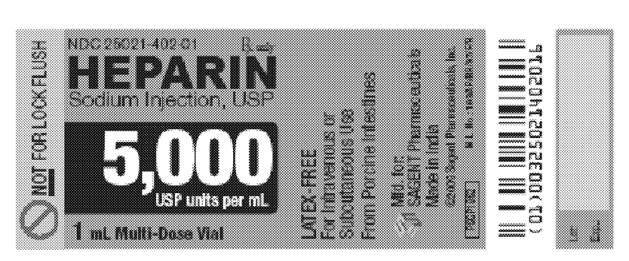
Images

Strengths | Shortcomings
This patent focuses on improving how prescription information is displayed, and in turn, using unique visual designs, individuals can easily distinguish between prescriptions. Changing the placement, font style, size, and orientation of text helps important information stand out. | This patent focuses mainly on visual factors to help individuals read prescriptions easily, as we’ve examined, elderly individuals are more likely to have a form of visual assistance and/or deteriorated eyesight. This heavy focus on visual elements will not help all individuals in our target audience. In addition, this leaves out color-blind individuals who cannot distinguish the different color labels. Ultimately, all these new visual elements might be overwhelming and could worsen the problem at hand.

Patent Researched 4: US20080150275A1
Citation: Raistrick, D. B. (2008, June 26). Auxiliary Prescription Label. (Note: The current patent status is “Abandoned”)

Summary: The invention allows for attaching a secondary label on top of an existing medicinal label that contains limited information compared to the original label, allowing for larger font sizes and an easy-to-interpret labeling system.

Critique: The patented item attempts to solve the problem by replacing the existing label with a much simpler one. It does this by increasing the font sizes in exchange for erasing other existing information there. While this is certainly simple and effective, it fails to address a couple of issues. For one, the information erased from the original label is deemed to be “unimportant” by the inventor. However, that information was most definitely there for a reason, as each piece signifies something. Additionally, it uses an adhesive to replace the existing label, which means that if someone wanted to access the information beneath, it may be impossible. However, this is very cost-effective and simple. This patented device shows us that when deciding what factors to focus on the most, we should not simply prioritize efficiency and cost because it may lead to other important factors being ignored. However, the idea of covering up the original label or doing something to it is something to keep in mind.
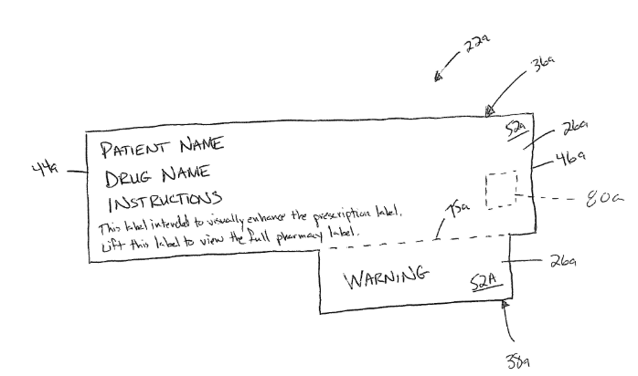
Images

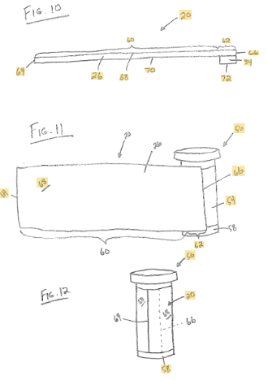

Strengths | Shortcomings
The invention is inexpensive and easy to use, making it practical for widespread adoption. The attachable sticker improves readability and helps users quickly understand key medication instructions. The design makes it efficient without requiring advanced technology. | The invention removes important information from the original label, which could lead to potential health errors arising. Since the attachable label uses adhesive and is placed on top of the original label, accessing the full information underneath may be difficult. This patent prioritizes simplicity over completeness, which may result in missing critical details.

Patent Researched 5: US12437852B1
Citation: Beaumariage, S., Capista, S., Desrosiers, L., Hoang, M. Q., Lambert, M., & Spears, J. (2025, October 7). System and method for audible prescription label information using RFID prescription packaging.

Summary: This patent describes a system developed by CVS to read aloud prescription label information to the patient/user using RFID technology embedded within or attached to the medication container. It features encoded packaging that would be suitable for the RFID technology to work, with a unique identifier for the medicine that is then scanned by any compatible mobile device to scan the medicine. The phone contacts the pharmacy database in order to pull out the information necessary, and then uses an audio script in the phone to read the information out loud.

Critique: The patented item solves the problem by shifting it from a simple graphic design issue, one where the font size is too small, to one related to digital accessibility. It makes the labels easier to read by simply making reading necessary, reading them out loud. Additionally, the mechanism is easily flexible and customizable due to the nature of how it works, allowing for volume control, speed control, language, etc., making it super versatile. The information depth of the label isn’t compromised, and the design is universal. Of course, as it is designed by CVS, it is definitely a well-thought-out and researched solution. However, it still has some flaws. For one, it depends on access to a smartphone and an app for the patient to use, and older generations may not be comfortable with that. Additionally, it requires access to an internet connection in order to access the database, unless it is stored locally on the device. Furthermore, there is a huge cost in implementing this. For one, embedding RFID technology within all chips is not cheap; however, granted, because this is CVS, they have the resources to do so. There may also be privacy concerns. However, this patent has provided us with very valuable insight. It shows us that a shift in perspective on technology could broaden our space for innovation and effectiveness. It also shows us that the readability issue is less about pure paper design, as the last patent assumed it to be. Our future research should explore alternative solutions, not purely limited to graphical improvements, and possibly advanced tech like AI.

Images
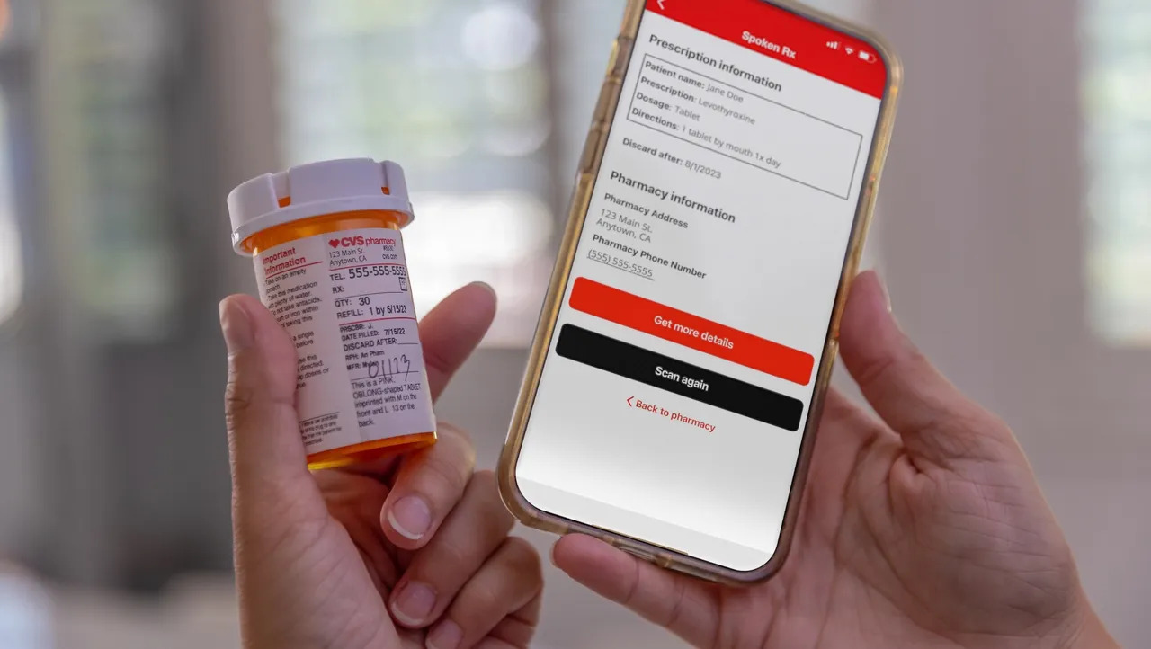
Strengths | Shortcomings
This patent preserves all prescription information while making it accessible through audio, eliminating the need for small text. The design’s flexibility makes it customizable for all. All of the information is extracted from a digital database, making all of the information accurate and up-to-date. | This design depends heavily on access to technology, which may be difficult for older users to navigate. The cost to implement is pretty high because of RFID integration and infrastructure requirements. Also, there could be privacy concerns related to storing and transmitting sensitive prescription data digitally.

Patent Researched 6: US7408465B2
Citation: Boss, G. J., Dawson, C. J., Finn, P. G., & Hamilton, R. A. (2008, August 5). Method of using RFID systems to help blind and visually-impaired individuals.

Summary: The patent utilizes RFID tags on prescriptions, allowing visually impaired individuals to scan these tags and hear information on prescription labels. Information can consist of drug names, warnings, and directions. This allows users to understand text that they can’t accurately read. Users set up a profile to their needs, and can choose whether they want to hear the information. Or, if they want to receive information through tactile feedback. In other words, vibrations and different vibrations signify different messages. When users set up their profile, they can choose to filter out the less important information and choose to prioritize any life-threatening information.

Critique: The patent relies on users carrying a battery-powered RFID reader, which can be inconvenient and difficult for older individuals. Also, the patent believes that users have good hearing, as audio is the primary method of communication. This is because vibrations may not be sufficient for conveying detailed instructions. The system adds hardware and maintenance costs, including replacing batteries and tagging every prescription. Since this patent was published in 2008, the technology may be outdated compared to modern smartphones. Additionally, requiring specialized equipment limits scalability and widespread adoption.

Images

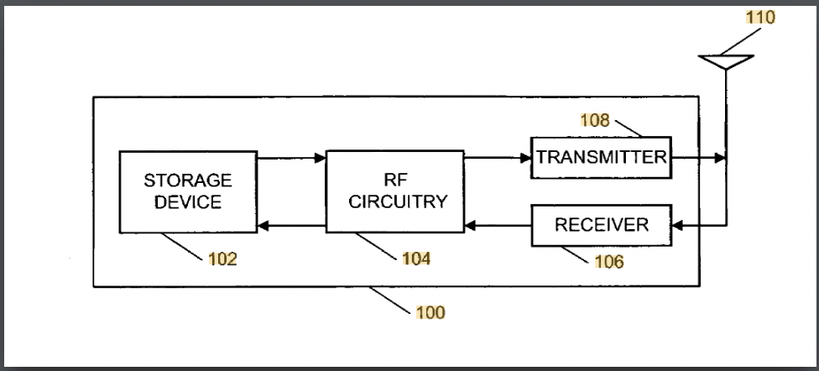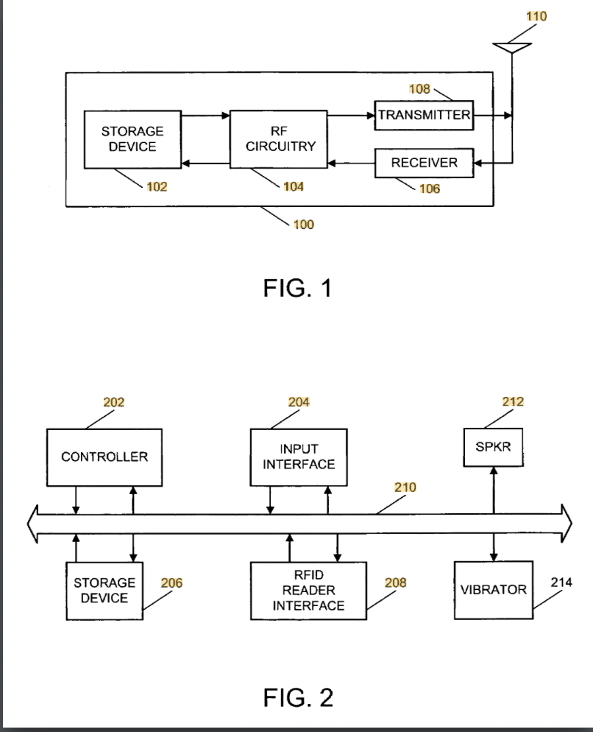

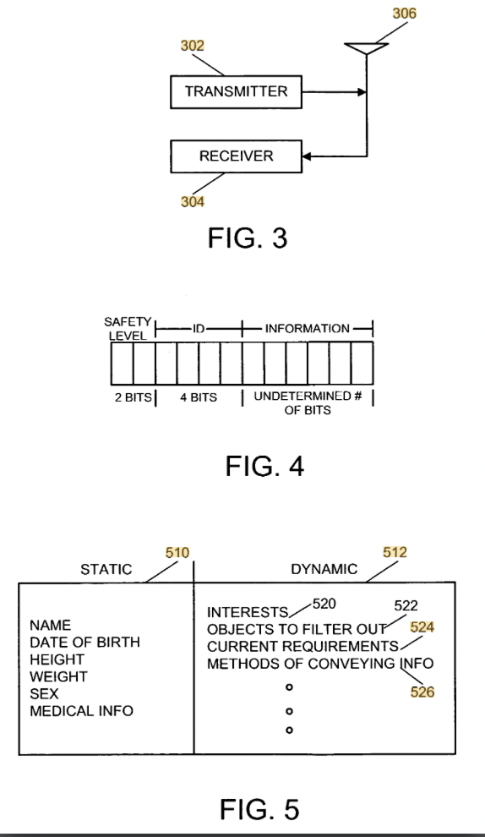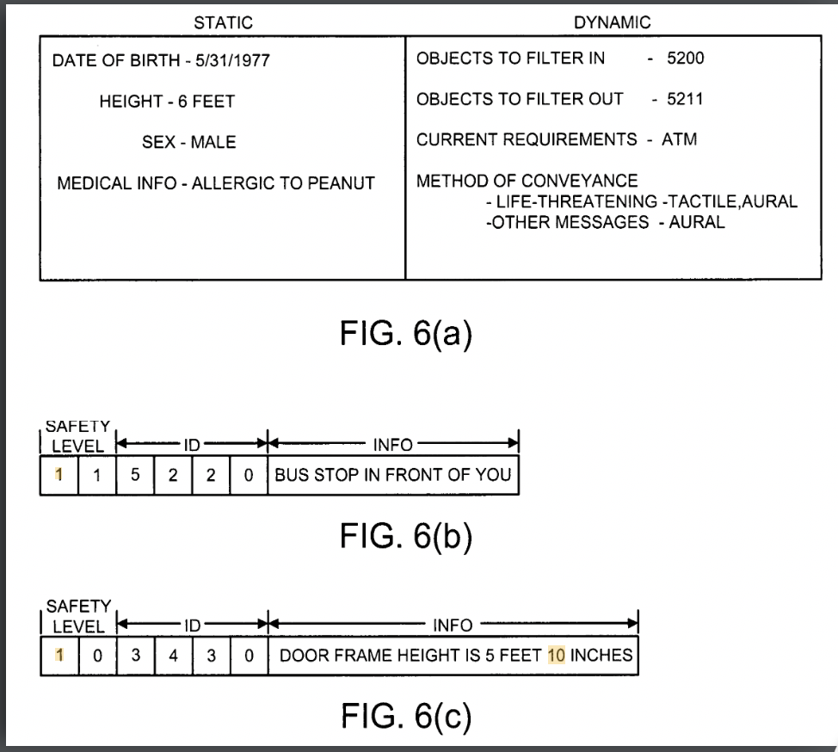
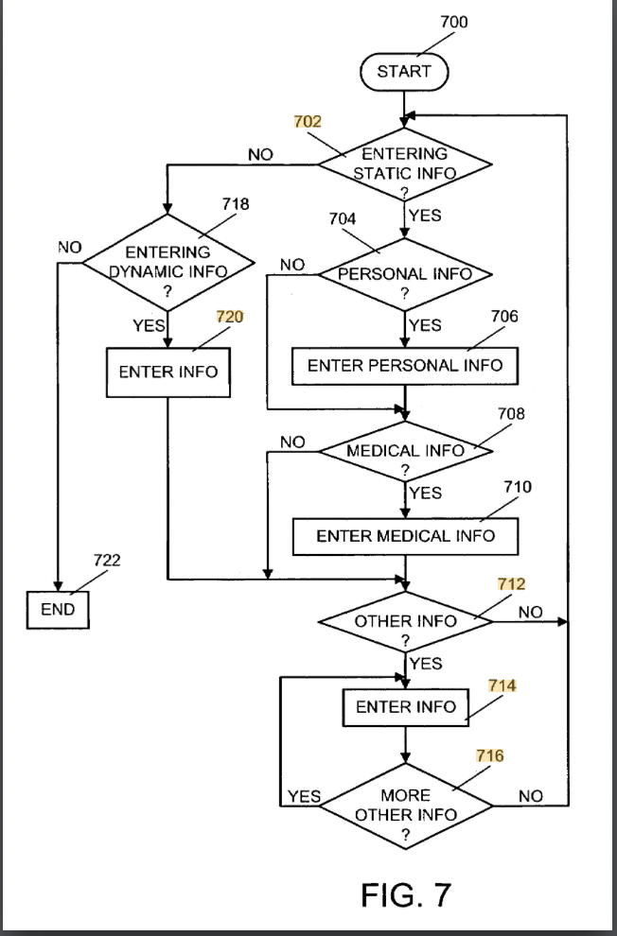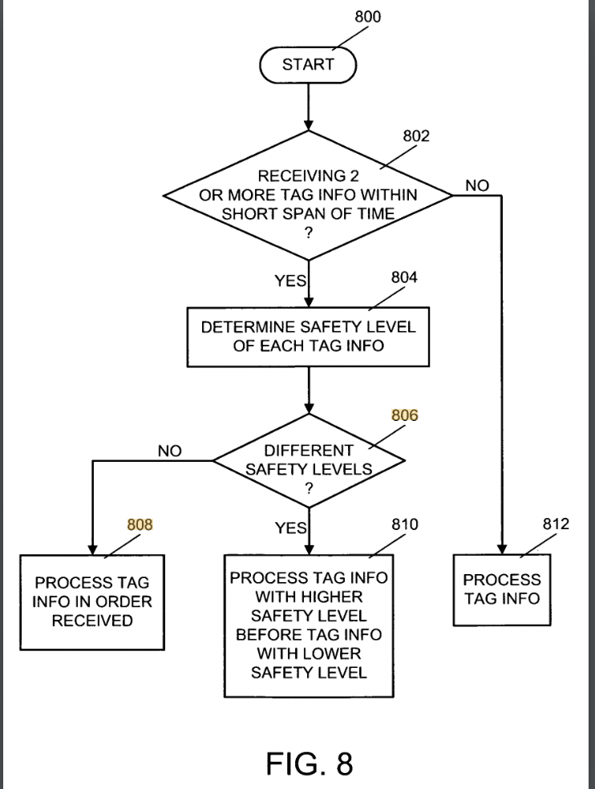
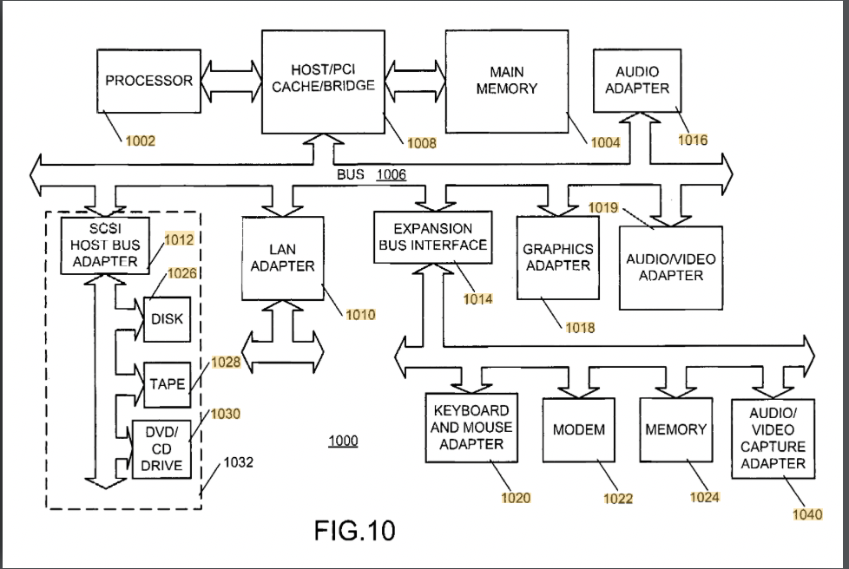

Strengths | Shortcomings
The patent effectively addresses accessibility by eliminating the need to read small prescription text, which is helpful for visually impaired users. The patent’s use of both audio and vibrations allows for customization based on the user's preferences. The ability to filter out less information while still prioritizing life-threatening warnings. This design focuses on user independence and safety. | The design requires users to carry an RFID reader everywhere they go, making it inconvenient for individuals. Also, this relies heavily on audio output and assumes that individuals have good hearing. The need to tag every prescription label and maintain batteries can increase the cost and complexity of implementing it nationwide. Lastly, since this patent was published many years ago, it may be outdated compared to modern solutions.

Element C: Presentation and Justification of Solution Requirements

Similar Solution Design Matrix
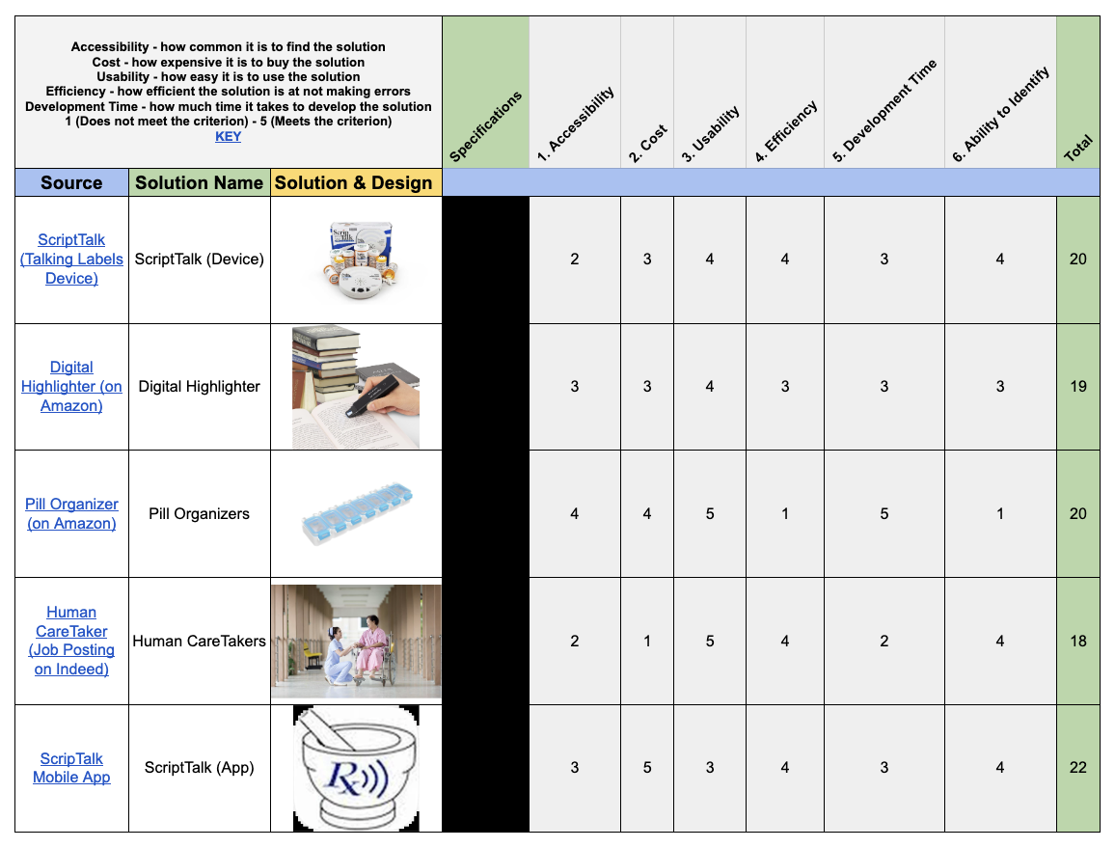

We researched 5-6 products that exist in the current market and compared them amongst each other to help us come up with our design requirements and help us start thinking of a potential solution. Our criteria were:
- Accessibility: The higher the number, the easier it is to access the solution. For example, the app is easily downloadable, pill organizers can be found at almost all retail stores, and the ScriptTalk device is located at local pharmacies in urban areas.
- Cost: The higher the number, the lower the cost of purchasing this solution.
- Usability: The higher the number, the easier it is to learn how to use the solution accurately. This category does not track if errors are made.
- Efficiency: The higher the number, the fewer mistakes the solution will make. For example, the pillbox relies heavily on the user’s memory to work accurately, while the ScriptTalk device will be more efficient due to its RFID labels.
- Development Time: The higher the number, the less time is required to develop and sell it to users.
While we pill organizers did receive a high score compared to the rest of the products, this solution is a complement to other solutions. For example, caretakers might use it to help them as they take care of their customers, or an individual will still need to remember what medication to take if they do not have a caretaker.

Design Goals into Clear Categories
At this stage of the design process, the team has not yet determined whether the final solution will be a digital application or a physical product. To allow flexibility while still defining clear expectations, the following design goals are written to apply broadly to both solution types, with additional goals included for app-specific and physical-product pathways.

- Form (size, shape, layout)
General Design Goals:
- Clear, intuitive layout that minimizes confusion
- Information should be organized logically and easy to locate
- Support accessibility for users with vision or cognitive challenges

App-Specific Design Goals:
- Screens should avoid clutter and unnecessary elements
- Buttons and texts should be large enough for easy interaction
- Navigation should require minimal steps

Physical Product-Specific Design Goals:
- Compact and easy to store
- Labels should be positioned for quick identification
- Physical layout should reduce the chance of selecting the wrong medication

- Function (what the solution should do)
General Design Goals:
- Clearly communicate medication name, dosage, and instructions
- Help reduce medication errors
- Support users managing multiple prescriptions

App-Specific Design Goals:
- Digitally store prescription information
- Provide reminders or alerts
- Support audio-based information delivery

Physical Product-Specific Design Goals:
- Physically organize medications in a clear system
- Provide visual or tactile cues
- Function without requiring advanced technology

- Performance (how well the solution should work)
General Design Goals:
- Perform consistently and reliably
- Easy to understand with minimal learning required
- Function accurately during daily use

App-Specific Design Goals:
- Respond quickly to user input
- Alerts should trigger at the correct times
- Audio output should be clear and understandable

Physical Product-Specific Design Goals:
- Labels must be clear and accurate
- Components should function smoothly over time
- Usability should not degrade with repeated handling

- Durability and Maintenance
General:
- Designed for long-term daily use
- Requires minimal maintenance from the user

App-Specific:
- Functional through software updates
- Prescription data should not be lost during updates

Physical Product-Specific:
- Withstand regular handling
- Materials should resist wear, fading, or damage

- Materials and Standardization
General:
- Follow relevant accessibility and usability standards
- Designed using commonly accepted design principles

App-Specific:
- Follow mobile accessibility guidelines
- Compatible with common operating systems

Physical Product-Specific:
- Made from safe, non-toxic materials
- Uses standardized symbols, icons, or labeling conventions

- Life Cycle and Environmental Impact
General:
- Designed to minimize waste and unnecessary replacements
- Long life

App-Specific:
- Reduces paper use by digitizing information

Physical Product-Specific:
- Materials should be recyclable or reusable when possible

- Aesthetics and Ergonomics
General:
- Design should be simple
- Easy to interact with for users with limited dexterity (same for physical-product specific)

App-Specific:
- Bright colors and adjustable text size
- Clean and modern interface

- Safety, Ethical, and Legal Considerations
General:
- Not provide misleading medical information
- Clearly state it does not replace professional medical advice

App-Specific:
- Protects user data and privacy
- Requires confirmation before deleting critical information

Physical Product-Specific:
- Not create new safety risks
- Clear warnings where misuse is possible

- Cost
General:
- Affordable and accessible
- Designed within school project budget limitations

App-Specific:
- Uses free or low-cost development tools

Physical Product-Specific:
- Uses inexpensive and readily available materials

- Customer Needs
General:
- Clear, readable, and understandable medication information
- Reduced stress and confusion
- Increased confidence in medication management

App-Specific:
- Convenience and portability
- Customizable reminders

Physical Product-Specific:
- Ease of physical interaction
- Reliability without needing technology expertise

Design Specifications
General Design Specifications:
- Clearly present medication name, dosage, and usage instructions
- Reduces the chances of medication errors
- Usable by individuals with vision challenges
- Simple enough to use without professional training
- Provide clear information before critical actions

App-Specific Design Specifications:
- Display text at a readable size with bright lighting
- Store prescription information securely
- Deliver reminders accurately at scheduled times
- Function without crashes during normal use

Physical Product-Specific Design Specifications:
- Labels that remain readable over time
- Safe for daily use
- Function without being reliant on the internet
- Physically distinguish medications in a consistent manner

Product or Technical Specifications
General Technical Specifications:
- Operate reliably during daily use
- Maintain accuracy when displaying or communicating information
- Support multiple medications at the same time

App-Specific Technical Specifications:
- Compatible with smartphone operating systems
- Load core functions within a short response time
- Data must carry over between sessions

Physical Product-Specific Technical Specifications:
- Fit within standard household storage spaces
- Products must not require complex assembly
- Materials must withstand frequent handling
- Components must maintain alignment and clarity

List Features
General Features:
- Clear organization of medication information
- Easy identification of each prescription
- Simple interaction requiring minimal steps
- Feedback to confirm user actions

App-Specific Features:
- Reminder notifications
- Audio reading of prescription information
- Adjustable text size
- Simple navigation between medications

Physical Product-Specific Features:
- Easy-to-clean surfaces
- Visual markers to guide correct usage
- Tactile indicators for identification
- Color-coding or physical separation of medications

List Constraints
General Constraints:
- Limited project timeline
- Limited budget
- Comply with safety guidelines
- Appropriate for an academic engineering project

App-Specific Constraints:
- Development is limited to team programming knowledge
- Rely on commonly available devices

Physical Product-Specific Constraints:
- Limited access to specialized manufacturing equipment
- Must use readily available markets
- Must be safe to build and test in a school environment

Define Parameters
General Parameters:
- Time required to understand how to use the solution
- Accuracy in identifying the correct medication
- User error rate during testing
- Overall user satisfaction

App-Specific Parameters:
- App response time
- Reminder accuracy
- Audio clarity
- Number of user errors during navigation

Physical Product-Specific Parameters:
- Time required to locate the correct medication
- Label visibility under normal lighting
- Wear after repeated use
- Ease of handling

Project Proposal
Engineering Project Proposal Presentation
This is our final presentation comprising of Elements A, B, and C which we will present in front of a panel of judges to receive feedback, support, and any assistance in helping us move forward.

Team Organization

Gantt Chart
PLTW Capstone Gantt Chart
The Gantt Chart contains both the approximate starting and ending weeks of each element. Each step of the element is directly imported from PLTW. Along with each step, a column consists of who the primary member of each step is.

Team Notebook
PLTW Capstone Team Notebook
The above link is for our team engineering notebook. This includes a description of day-to-day activities done in class regarding our projects, documentation, and research.

Team Norms & Responsibilities
Team Responsibilies
Based on our strengths and abilities, we divided the tasks amongst our group members. Despite only two individuals assigned to one responsibility, we also expect all teammates to assist when needed.

Team Norms:
- Listen to input from all team members
- Follow meeting schedules and project timelines protocols
- Don't be defensive with your teammates
- Support each other
- Be honest with each other about ideas and challenges
- Pay attention to what other team members need and help them do things for themselves
- Celebrate success and have fun!
- Don't be biased
- If you have an idea, SPEAK UP
- If you find new information that could help the project, let the team know
- Critcize each other to improve yourselves
- Finish the work on time
- Let others know if you can’t complete an assignment on time
These are our team norms, an agreed set of rules and beliefs, that we will utilize to manage order and efficiency of our team. This will not only help us stay on track for our project, but also holds us accountable. If any problems arise, we will utilize PLTW’s Conflict Resolution Strategy which can be accessed here.

